(Approx. 1772 words)

SLR Lens Evolution
Find out if your film SLR lenses will work when attached to a modern digital SLR body
By John Krout, Presenter & Newsletter Contributor
Potomac Area Technology and Computer Society
www.patacs.org

At a recent PATACS meeting, we had an interesting discussion about film SLR lenses and the extent of their compatibility with modern digital Single Lens Reflex (SLR) cameras during my presentation on close-up and panorama photo techniques at the PATACS+OPCUG meeting on September 18, 2021. Later that day, I decided to describe what I know about SLR lens evolution. This information will help you figure out whether film SLR lenses you own now will work when attached to a digital SLR.

I will describe the evolution of lenses in four stages. This approach is strictly my own. I have no idea if SLR camera companies would consider this accurate or complete.

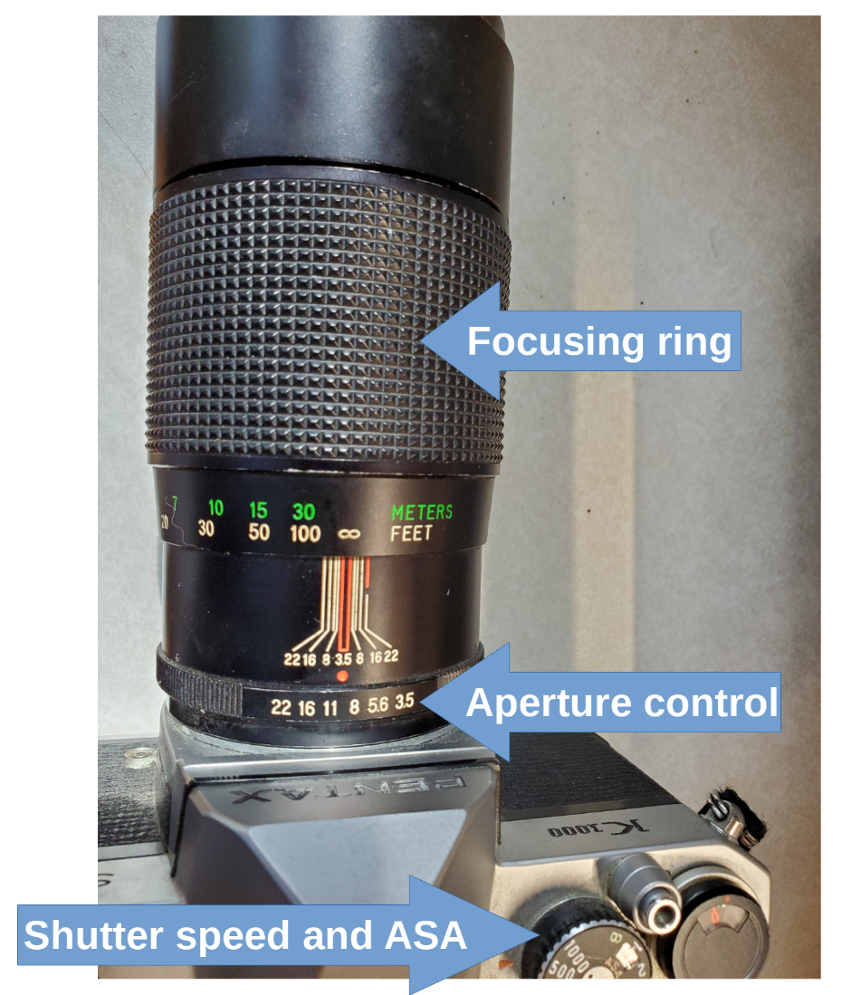
STAGE 1: FULLY MANUAL
In 1971, I was given an Asahi Pentax 35mm film SLR when I graduated from high school. The SLR lens mount included simple mechanical features to interact with the SLR body. In addition, the lens had two user controls: one for aperture size, also known as f/stop, and a knurled ring around the lens for focusing.

An example in illustration 1 is a Vivitar K mount 200mm f/3.5 lens that I purchased in 1973 for my Pentax Spotmatic film SLR. I used that lens for 26 years. Now the lens resides on my Pentax K1000 35mm film SLR. I also own a 24mm lens and a 50mm lens, both Pentax brand.

On top of the SLR body, there were two concentric user control dials. One set the shutter speed, and the other set the film's sensitivity, then known as ASA.
Illustration 11

We use the same scale for film sensitivity now but call it ISO because the International Standards Organization (ISO) adopted the sensitivity scale originally adopted by the American Standards Association (ASA).

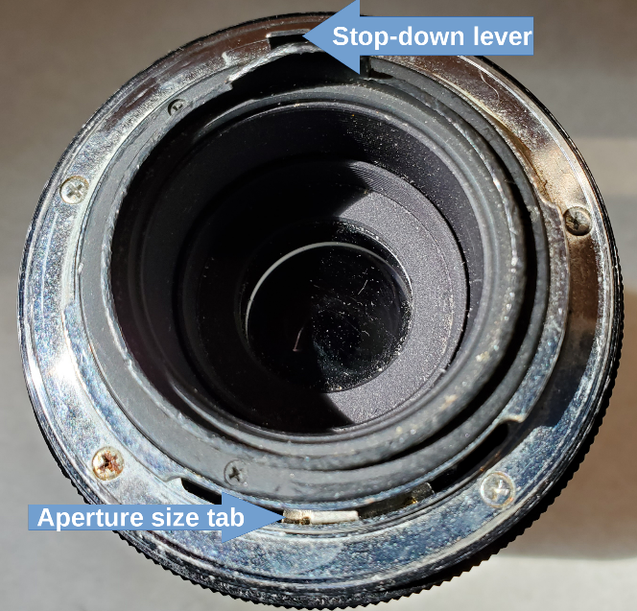
You can see the back end of that 200mm lens in illustration 2. It includes two mechanical features. The first, at the bottom, is an Aperture Size tab that is moved left or right in its slot arc when the photographer uses the lens control to adjust the aperture size. That tab enables the SLR to include the aperture size in its exposure calculations. The second is a spring-loaded Stop-down lever with a very useful purpose. It keeps the lens at the widest aperture size, f/3.5, so the photographer can aim and focus while seeing the brightest possible image through the SLR viewfinder.
Illustration 21

When the photographer pushes the shutter button, the SLR body moves that lever to one side, and that movement forces the lens to reduce the aperture size to the aperture size control setting. When the shutter closes, the SLR body releases that lever and the spring forces the lens to revert to its widest aperture. A button battery powered the SLR body light meter.

STAGE 2: AUTO EXPOSURE
The next enhancement in lens design was the introduction of auto-exposure. I believe this enhancement came along in the 1980s. Instead of a lens dial for manual control of aperture settings, the lenses designed for auto exposure had a motor-driven aperture. The SLR body, containing the light meter, would use the lens motor to set the aperture size so that, with the shutter speed and sensitivity settings, the aperture would correctly expose for the scene in front of the lens. Of course, the motor was powered by a battery in the camera. Batteries in cameras began to grow. Mechanical features were removed from lens mounts, and electrical contacts were added to lens mounts, so the camera could send power to the aperture motor and control the motor. Aperture size control moved from the lens to the SLR body.

Lens price went up due to the aperture motor included in each lens. In addition, SLR batteries became bigger and more costly to power the lens motor.

STAGE 3: AUTOFOCUS
The next significant change in lens design came when auto-focus was introduced. Lenses changed again. Manual focus was accomplished by rotating another lens dial, which moved a lens element back and forth with the lens body. The automatic focus was achieved by adding yet another motor in the lens, this time to move back and forth that same lens element for focusing, along with control circuits in the SLR to figure out what position of that lens element maximized sharp focus. Of course, that motor in the lens required more electrical contacts in the lens mount to enable the camera to reposition that lens element to find the best focus.
Most of the logic circuits do that automatic focus work by maximizing contrast.

Lens price went up again because of the automatic focus motor placed in each lens. And SLR batteries became bigger still.

STAGE 4: ZOOM
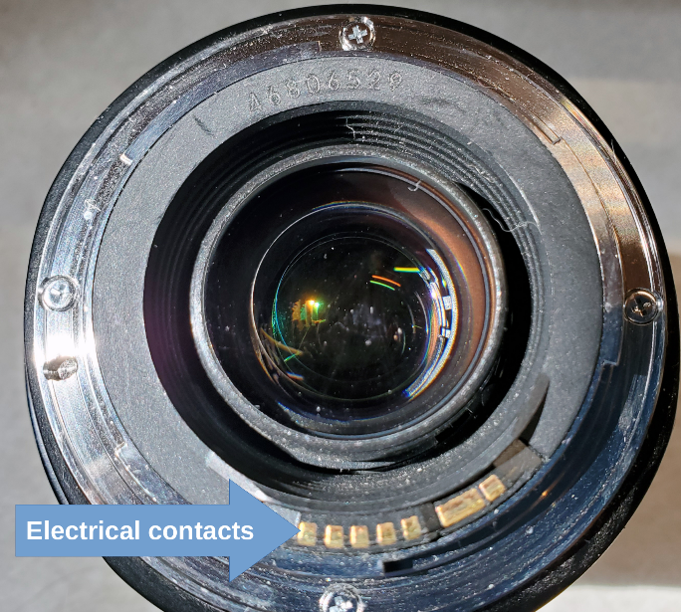
I am unsure when optical zoom lenses are available for 35mm film SLRs. It is possible that Stages 3 and 4 happened at about the same time. First, camcorder makers figured out how to add zoom to camcorder lenses. When I bought a VHS-C Panasonic Palmcorder in 1993, most camcorders sold in the US had a zoom lens. Like Canon, some camcorder makers also made SLRs and soon figured out how to add zoom to SLR lenses.

That optical zoom feature did not add another motor to the lenses, but it did add another manual control dial on lenses and more internal lens elements to move back and forth. Also, since zoom affects the focal length and therefore f/stop, the lens had to communicate focal length to the SLR for exposure purposes.
Illustration 31

The lenses got bigger, and prices went up again.
You can see an example of a Canon EF lens mount in illustration 3. Notice the gold electrical contacts at the bottom. The lens mount has no moving mechanical features. However, manual focus is still possible, and a switch labeled AF/MF (or A/M) on the lens allows the photographer to disable automatic focus.

HOW DOES THIS INFO HELP YOU?
If you own a film SLR and lenses for that film SLR, will those lenses be compatible with a digital SLR body? Stage 3 and Stage 4 lenses are likely to be compatible; those lenses that include both auto-exposure and auto-focus. You have some hope for using Stage 2 lenses, those that include auto-exposure, though you will have to continue focusing manually while using those lenses.

The quickest way to test the compatibility is to take your camera and lenses to a camera store and ask the staff to tell you if your lenses will work on a modern digital SLR.
Here are examples from my own experience.

I bought two Canon lenses for my new Canon Elan IIe 35mm film SLR in 1999. Those lenses had been designed in the 1990s using a Canon lens mount designed for auto control of both exposure and focus. The mount is known in the US by the letter EF. Both were zoom lenses, so they can be called Stage 4 lenses. Since my Canon digital SLRs include the same lens mount, I use the same lenses on my Canon digital SLRs.

Would my Pentax K mount Stage 1 lenses work on a modern Pentax digital SLR? No, those lenses lack both the motor-driven aperture control and the motor-driven lens element for auto-focus and lack the electrical contacts for both motors. The Pentax lens mount compatible with modern Pentax digital SLRs is called KAF4.

How about Stage 2 lenses? It depends on whether the electrical contacts are precisely in the same place and the same shape and size in Stage 3 and 4 lenses for the same lens mount. Take the lenses to a camera store and ask.

ADAPT OLD LENS TO A NEW MOUNT?
I seem to recall seeing advertisements for lens mount adapters. Adapters might, for instance, enable the use of an auto-everything Canon EF lens on Canon SLRs with later lens mounts, such as a Canon M or R series SLR. There is even a third-party lens mount adapter for "attaching" a Canon lens to a smartphone, essentially putting the lens in front of the smartphone lens. But unfortunately, that adapter is almost as expensive as a Canon EF lens.
Suppose you have Stage 2 lenses, and you find out those no longer work on digital SLRs. There may be adapters for attaching Stage 2 lenses to a digital SLR, but of course, auto-focus would not be possible. You would still have to focus the lens manually. For many photographers, including my son, that is the preferred focusing method anyway.
If you want to look for such an adapter, keep in mind that Google is your friend. And expect the adapter to be expensive.

ABOUT STICKER SHOCK FOR STAGE 4 LENSES
Let's assume that you are forced to buy modern Stage 3 or Stage 4 lenses for a digital SLR body. This is because lenses do not wear out from repeated use, unlike a shutter in a digital SLR body.

Consider buying used lenses. These generally cost less than new lenses. Some local camera stores buy and sell used lenses. The big New York City online stores buy and sell used lenses. I use Craigslist to find used lenses; those often sell for less than the price at stores.
First of all, find out how much a new version of the same lens costs, the retail price.
If you meet directly with an individual lens seller or go to a local camera store, you can inspect the used lens and determine if there are scuffs or scratches, especially on the glass and the lens mount. Then, of course, you can try it out on your digital SLR body too. Absent evidence of rough handling and failure to work while attached to the SLR body, the lens is probably worth buying if the price is 30% to 70% below retail.

I have put my favorite Canon lens through some rough situations occasionally. I have broken it three times. Every time, I have found the same lens for sale locally on Craigslist, inspected the lens for sale, and purchased it for far less than the new-lens cost. Keep in mind that sellers on Craigslist expect to be paid in cash.

ABOUT THE AUTHOR: John Krout is a retired software engineer who has been writing about creative uses of personal computers since the early 1980s. Now he also writes about tablets, smartphones, and digital cameras. He lives in Arlington, Virginia, with his son, many computers and digital cameras, and too many cats.

